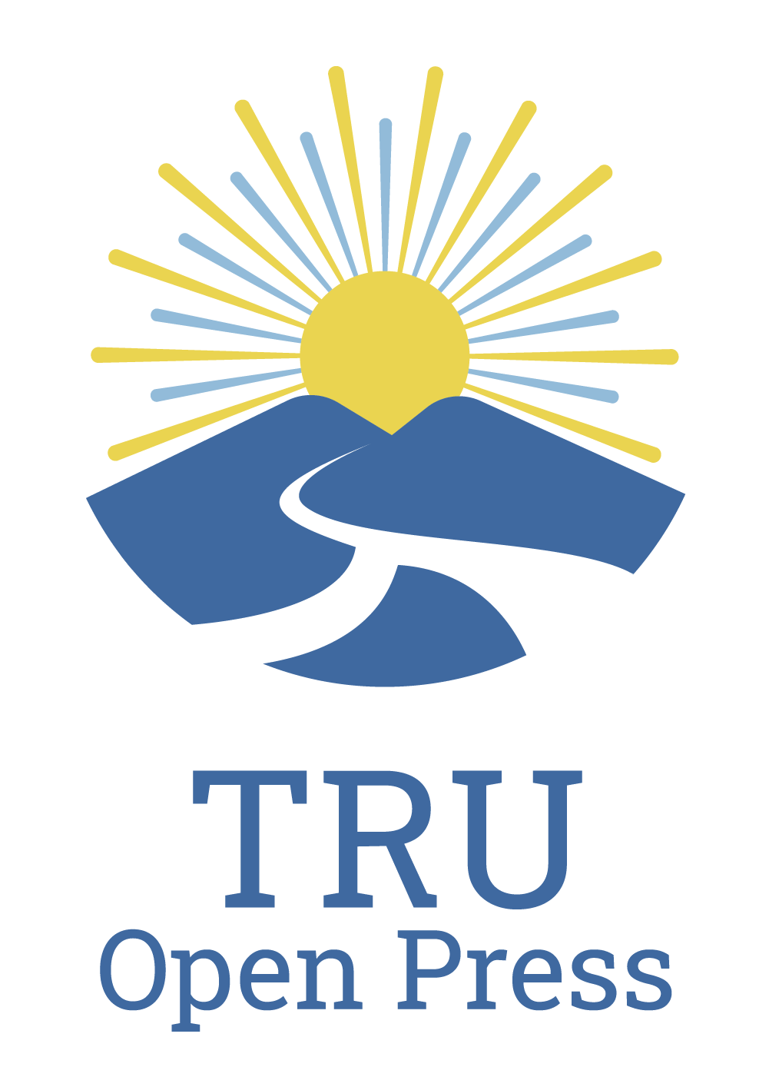

Intro to Ethics - Student Research Partners

Transcript

00:00:01:07 - 00:00:10:21
Riley
Introduction to Ethics. Student research partners. Interview. Introduction.

00:00:10:24 - 00:00:15:26
Calum
I'm Calum McCracken. I'm in the human Rights and social justice master's program.

00:00:15:28 - 00:00:21:13
Hunter
I'm Hunter. I'm a fourth year social work student in the BW program at Thompson Rivers University.

00:00:21:15 - 00:00:46:23
Calum
Basically, what we were tasked with doing was condensing big ideas in the in our in our book Introduction to Ethics. We split up various roles. Hunter took the value of philosophy for moral and ethical relativism and deontological ethics and so on. And then I took contractual ism utilitarianism. These are big ideas. Moral agency and responsibility, moral luck.

00:00:46:23 - 00:01:01:10
Calum
And then we tried to make them accessible to, first year philosophy students and take sources that we got from other open educational resources and, and put them also into the open press site.

00:01:01:13 - 00:01:31:01
Hunter
Yeah. Like our, our resource was basically for like for their second year students in like taking a first time philosophy course. So like Calum was saying, like we are trying to create like a pedagogical tool to help reduce some of the barriers around learning these ideas. You know, we all know how expensive textbooks can be, and especially in a philosophy course where there's multiple thinkers being covered in a semester, sometimes you don't get the full picture of those ideas from like, an anthology, let's say, and students might feel really drawn towards a particular idea.

00:01:31:01 - 00:01:48:01
Hunter
So they go out and try to buy the book. But if they're drawn to 4 or 5 really interesting thinkers, you know, each of those books is like $30, $50 a piece. And so that's a really like huge cost for students to try and get really good learning. So that was the primary goal of of the book, I would say.

00:01:48:01 - 00:02:06:10
Hunter
And then, I mean, our team was so great to work with. They like helped us navigate through the whole process. You know, navigating through the Open Press Toolkit. They were really great points of contact for like feedback, very responsive to like our questions and concerns and like helping us copy, edit the work at the very end was like super important.

00:02:06:11 - 00:02:20:25
Hunter
You know, it was a lot of work to go through and read all of the things, and after a while you start reading the same writing over and over again. You just get blind to mistakes. So that was a really, really valuable piece at the end. And then, you know, formatting this book was also really important to us.

00:02:20:26 - 00:02:40:04
Hunter
There's kind of nothing worse than being like a new undergrad and being in a new environment, a new course, and trying to learn to how to navigate and read the material can be really stressful. So it was really important to have like really good formatting in the book, like through table of contents and stuff like that. And they were so patient with us and us like learning the ropes of everything.

00:02:40:05 - 00:02:56:20
Hunter
There was one point that we were, looking to like, build a table of contents, and I believe it was Jessica that sat down and went through like anchors with us and how to format those in the book. And that was just like such a light bulb moment for our team to be able to, like, have the good formatting in the book.

00:02:56:21 - 00:03:00:25
Hunter
So yeah, overall, they were so great to work with.

00:03:00:27 - 00:03:08:24
Riley
Have you encountered any challenges or limitations while working on this project? If so, what were they?

00:03:08:26 - 00:03:36:29
Calum
So yeah, the writing process, condensing information, all that kind of stuff came relatively easy for, for for me. But I'm woefully bad. The technological side, all the help from Pressbooks and Hunter really took the lead on organizing all the information, getting it all, into an accessible format for the website. And Hunter was saying in the last question to copy editing from Open Press was instrumental.

00:03:37:05 - 00:03:38:16
Calum
Truly?

00:03:38:19 - 00:03:52:03
Hunter
Yeah. I mean, like Helen was saying, like it was, I guess, like some of the the big limitation for me, it was just like kind of making sure, like all of our formatting was like on the same page, so to speak. Like we were all just very busy over the summer with our own projects and things going on.

00:03:52:03 - 00:04:13:13
Hunter
So just like the communication and not it being like an in-person thing, I think was a bit of a limitation for us. But, you know, another was kind of like getting the scope of the project really honed in to, at the very beginning, the possibilities with this kind of work seem endless from like a open resource perspective. And there's so much potential to do, like really great things with it that we like.

00:04:13:13 - 00:04:28:17
Hunter
I think it was super important for us to like, have a clear vision and goal at the very beginning. I don't know how much of a limitation that is, but just a lot of discussions around like what we want the book to look like. And, the purpose it's going to serve. So yeah.

00:04:28:20 - 00:04:37:02
Riley
Have you had a chance to share your experiences with your peers? What were their thoughts on this project?

00:04:37:04 - 00:05:02:00
Hunter
So like because I'm a social work student, not all of them are super familiar with philosophy, but once I explain the kind of logic behind the OER resource, as you know, supposed to be like, creating equitable access to education, that's something that really resonates with a lot of them. So they've all thought it was really, really cool that I was able to be a part of this project and like, just such a good experience and really great on the resume as well.

00:05:02:01 - 00:05:06:05
Hunter
You know, it was it was just really good to hear their feedback and they were all pretty excited about it.

00:05:06:05 - 00:05:26:17
Calum
So yeah, I definitely reflect those comments as well. Another highlight, I guess, was revisiting some old thinkers that I haven't been able to, revisit in a while and going through all that content and sort of giving myself, a first year refresher on philosophy that I didn't think I would have the privilege of doing. Again.

00:05:26:20 - 00:05:33:15
Riley
How thoroughly does the project address fairness, inclusion, and accessibility?

00:05:33:18 - 00:05:56:01
Hunter
You know, I think the project addresses these pretty adequately. You know, we left a disclaimer in the book at the end or at the beginning saying that, like, although it's designed for students in a philosophy course, anyone's welcome to use this resource and adapt it to their needs as they see fit, or just use it as a general starting point for the person who is like, not in a university setting, has just curious about philosophy.

00:05:56:03 - 00:06:14:14
Hunter
I think this really allowed us to like, expand the boundaries of the project beyond the university walls and kind of engage people in a broader perspective. You know, like, of course, with any project, there's going to be some barriers that come up in hindsight. You know, I wish I would have thought about that. While I was doing the project that I kind of address those issues then.

00:06:14:14 - 00:06:34:14
Hunter
But I think this is the really great thing about Oers is that, you know, although we might have missed something, we can always go back and revise and edit the work to address those things that come up. It's not like a textbook where you're kind of locked into like, second edition, third edition, fourth edition, where you have to spend a whole bunch of time republishing a book to try and address things as they come up.

00:06:34:17 - 00:06:48:21
Hunter
We can go in and edit it in, like, real time, or sit down and brainstorm a bunch of things to go back and edit it, at another later date. It's really quick and easy, and we don't have to, like, reprint a whole book to do it. So yeah.

00:06:48:23 - 00:07:21:26
Calum
Yeah, absolutely. If I just add on the prohibitively expensive, format of traditional textbooks and moving beyond that through this platform has been very gratifying. Also, on the content side, we aren't just limiting our inquiry and, the resources we share to simply, you know, old Greek philosophers or, you know, romantic era philosophers. We have new voices, postmodern voices, marginalized voices that add to the chorus of this inquiry.

00:07:21:26 - 00:07:25:10
Calum
That's really useful. I believe, as well.

00:07:25:13 - 00:07:30:24
Riley
What might a future project scope entail?

00:07:30:26 - 00:07:54:02
Calum
We were hoping on getting an audio visual formatting into into this, and as Hunter was saying, the feedback will also inform future iterations of this project. Say if there's another author or there's content or a particular framework that a student would like to see, there's a possibility, given this format, to include it.

00:07:54:05 - 00:08:27:01
Hunter
Yeah, I think like, I guess one of the things personally, just like having gone through this course before, the instructor kind of asks for like resources for study projects at the end. So you kind of have to come up with your own independent research on certain topics. You know, I think a future project, it would be really cool to see kind of like a area that addresses some of like the broader concerns that students might pick from a topic and just have some, like, really awesome resources to check out that aren't necessarily part of the course curriculum, but students can just go check those out and use them in their research as well.

00:08:27:02 - 00:08:31:23
Hunter
I think that would be a really interesting thing to have in the book for sure.

00:08:31:26 - 00:08:43:20
Riley
Did you know about TRU Open Press and open Educational resources before you were involved in this project? If so, how did you learn about them?

00:08:43:22 - 00:09:06:20
Hunter
Sort of. I like there has been like an open education resource used in the philosophy program before. I think it's just kind of like a broad picture of like Western philosophy kind of. And it's got a bunch of different categories that students can use. So I knew it was like a free textbook, but I wasn't really sure if it was like about oers in general.

00:09:06:20 - 00:09:17:11
Hunter
As I approach the project a bit more, I got a little more familiar with what they were. But at the beginning I didn't have like a super great idea about what they were so.

00:09:17:14 - 00:09:39:27
Calum
Yeah, same with me. I didn't have too much experience. Most of my education was traditionally through getting the primary source and trying my best to parse it out. So this, new tool makes that so much more accessible, and it doesn't prohibit people from seeking out the primary source themselves. But rather it kind of augments their understanding.

00:09:40:00 - 00:09:48:04
Riley
What was your experience like using TRU Open Press and receiving support from the team?

00:09:48:06 - 00:10:13:01
Hunter
It was really good. You know, I honestly have no, complaints to field. It was like I had nothing but great support every time I had a question, it was answered within the day. If not like early the next morning, they were very responsive. And like I was saying earlier, they're very patient with like our stumbling blocks and learning of trying to figure out all the different tools and the resource in the OCR toolkit.

00:10:13:01 - 00:10:23:04
Calum
So yeah, definitely the the velvet glove of the, the open press team was, really nice.

00:10:23:07 - 00:10:34:27
Riley
How do you think open educational resources will improve students education? How would the quality of the education differ without OCR?

00:10:34:29 - 00:10:57:06
Hunter
I think we are improve students education. Just by having like a really easily accessible resource, like the tip of their fingers. Everybody's on their phone nowadays, you know, and the really awesome thing about Oers is that if you're on the bus and you've got like an hour long bus ride or something to get to the university, you don't have to haul around a 30 pound textbook.

00:10:57:07 - 00:11:17:26
Hunter
You can just pull out your phone and like, catch up on the readings, you know, before, right before class. Not that any of us ever do that. But yeah, it's I think it's just like a really awesome way to, like, make the material very accessible for students at, like, any time or place. I think the quality of education without it would be, I guess, lacking.

00:11:17:26 - 00:11:32:10
Hunter
Like, I, I'm not sure I can go back to like having an anthology placed in front of me, of a book that's got a thousand pages worth of different content that I need to read through. It's intimidating. It's yeah, it just makes it a better experience for my opinion.

00:11:32:13 - 00:11:56:01
Calum
I say it gives, students access to a vetted level of, source information that say, we would get in a traditional university experience, but have it open and accessible. With so many things online nowadays that the sources are dubious at best. This provides a way for students to have a way to access information that isn't prohibitively expensive.

00:11:56:01 - 00:12:10:02
Calum
Like I said before, that is also been curated and correct in terms of the information that you're being presented. So, and particularly in these times, that's a pretty valuable resource.

00:12:10:04 - 00:12:17:12
Riley
What types of open educational resources would you like to see in the future?

00:12:17:14 - 00:12:43:19
Hunter
Oh, man. You know, I don't know how feasible this is, but I think like an audio book over would be really cool to see. I know that takes a lot of time and effort to, like, sit and read through. Material like that, but just to address some of the, like, more auditory learners among us. I think it would be really cool to have an OER that, you know, had spoken word of some sort, and I guess that's kind of like the only one that I really, I really think about.

00:12:43:19 - 00:12:59:26
Calum
But more philosophy, more critical theory, I think it's really valuable. I mean, I may be coming from a biased perspective, but I think it's really valuable to have that prism of understanding for young people who want to access it. I think it's really valuable.

00:12:59:29 - 00:13:21:04
Hunter
Yeah. On that point to, like in the social work program, there are no open education resources. As far as I'm aware, at least none that I've encountered in my experience at the school. So I think having more oer as like Caitlin's alluding to, to kind of expand more into different disciplines would be really, really awesome.

00:13:21:07 - 00:13:23:25
Riley
Thank you for the interview, Hunter and Calum.

